



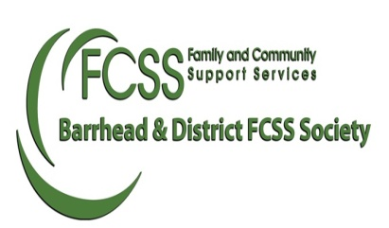

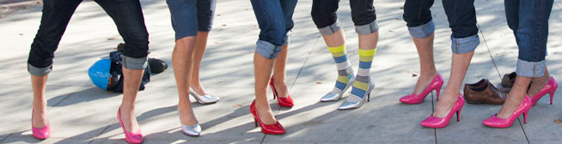

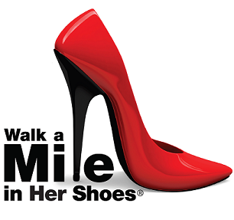__

*Fax Form back to person that made the challenge or to FCSS @ 780-674-4571*

**Check Here to accept Challenge!!**

**Prizes to be won: most $ raised by an individual or group, fastest man in heals and more!!!**

**Speak out against Men’s Violence toward Women and Children!**

**To register, call FCSS @ 780-674-3341**

_____________________________________________________________________________

Is participating in the Annual Walk a Mile in Her Shoes on May 10, 2019 and is

Challenging **YOU** to a friendly competition.

Team Name:___________________________________

**Monies raised will support the Barrhead FCSS Family Violence Prevention Program**

____________________________________________________________________________

**You’ve Been Challenged!!!!**

